

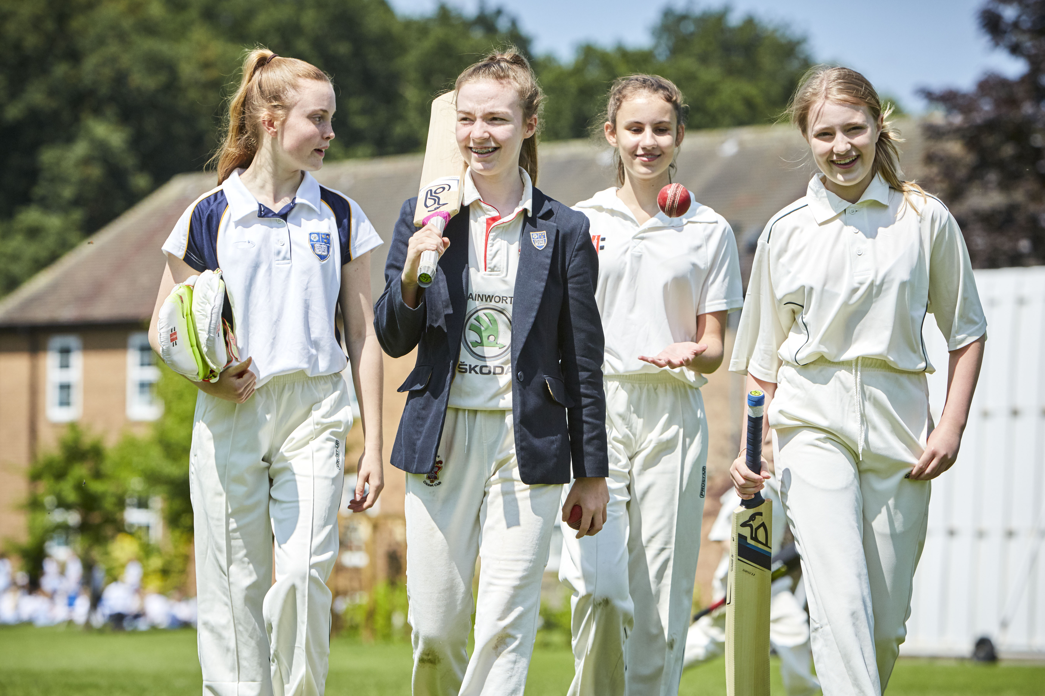

Sportswear

Policy

Your child will be allocated a House from Reception, or the year they enter school. (Please check with the school which house your child is in.)

Availability

Items marked with an asterisk (*) must be purchased from the Schoolblazer website (see the link from the Hill House website or go to www.schoolblazer.com).

The Friends of Hill House School run a second-hand school uniform shop which is open every Friday 8:15am until 9.00am. This can be accessed via Main Reception.

Identification

It is essential that all items, including shoes, underwear and towels are marked with the owner's name.

Please note; cricket bats, pads, etc are not necessary as the school provides all equipment. Any equipment purchased by individuals must still be contained within the school games bag and is brought to school at the owner's risk.

NURSERY
BOYS AND GIRLS

All Terms -

* White crested Polo shirt
* Navy PE shorts
* Navy crested sweatshirt
* Navy jogging bottoms
White socks

Please note: Hill House sport kit is required for Mini Kicks and RuggerEds (if children do not have the kit provided by the activity provider) and is also required for events such as Nursery Sports Day.

RECEPTION TO YEAR 2
BOYS & GIRLS

All Terms -

* White crested Polo shirt
* Navy PE shorts
* Navy crested sweatshirt
* Navy jogging bottoms
White socks
Black slip on plimsolls
* Navy swimming trunks/costume

Other items required:

* Navy swim bag
Towel

YEAR 3 TO 11
BOYS

Michaelmas Term –

* House reversible rugby shirt
* Hooped games socks
* Navy crested performance rugby shorts
* Tracksuit (crested tracksuit top and navy training pants with gold piping)
* Navy crested mid-layer
Football/Rugby boots
White Trainers

* White crested Polo shirt
White sports socks
* Navy swimming trunks (Elite Squad only)

Equipment -

* School games kit bag
Boot bag
Towel
Gum shield
Shin pads
RFU Shoulder pads (optional)

Lent Term -

As above except:
* Navy PE shorts with gold piping
Astro boots

Equipment –

Shin pads

YEAR 3 TO 11
BOYS CONTINUED

Summer Term -

As for the Michaelmas term, plus:

* Cricket trousers
* Crested cricket shirt
* Crested cricket slipover
White cricket shoes (for team players)

Please note: this applies to Year 6 to Year 11 boys representing the school (U11A to 1st XI)

Equipment -

* School games kit bag
Towel
Cricket abdominal protector
Cricket boots (optional, but must be non spike)
Pads/Gloves (optional)
Bat (optional)
Helmet (optional)

Please note: Football boots are acceptable but will need studs changing to all metal ones for rugby.

YEAR 3 TO 11
GIRLS

All Terms –

* House Polo training shirt

* Navy Skort with gold piping
* Hooped games socks
* Tracksuit (crested tracksuit top and navy training pants with gold piping)
* Navy crested mid-layer
Astro boots for Hockey
White trainers

* White crested Polo match shirt
White sports socks
* Navy swimming costume (Elite Squad only).

Equipment -

* School games kit bag
Boot bag
Towel
Gum shield
Shin Pads
Hockey stick (optional)
Astro boots

Summer Term Equipment –

* School games kit bag
Towel

SIXTH FORM

For team players, required kit and equipment will be as for Years 9 – 11. Please note that the tracksuit top and bottoms are compulsory.

For those simply pursuing sports activities for recreational purposes, students will require a house top for their appropriate house and to dress sensibly and appropriately for their chosen activity in blue/white colours.

